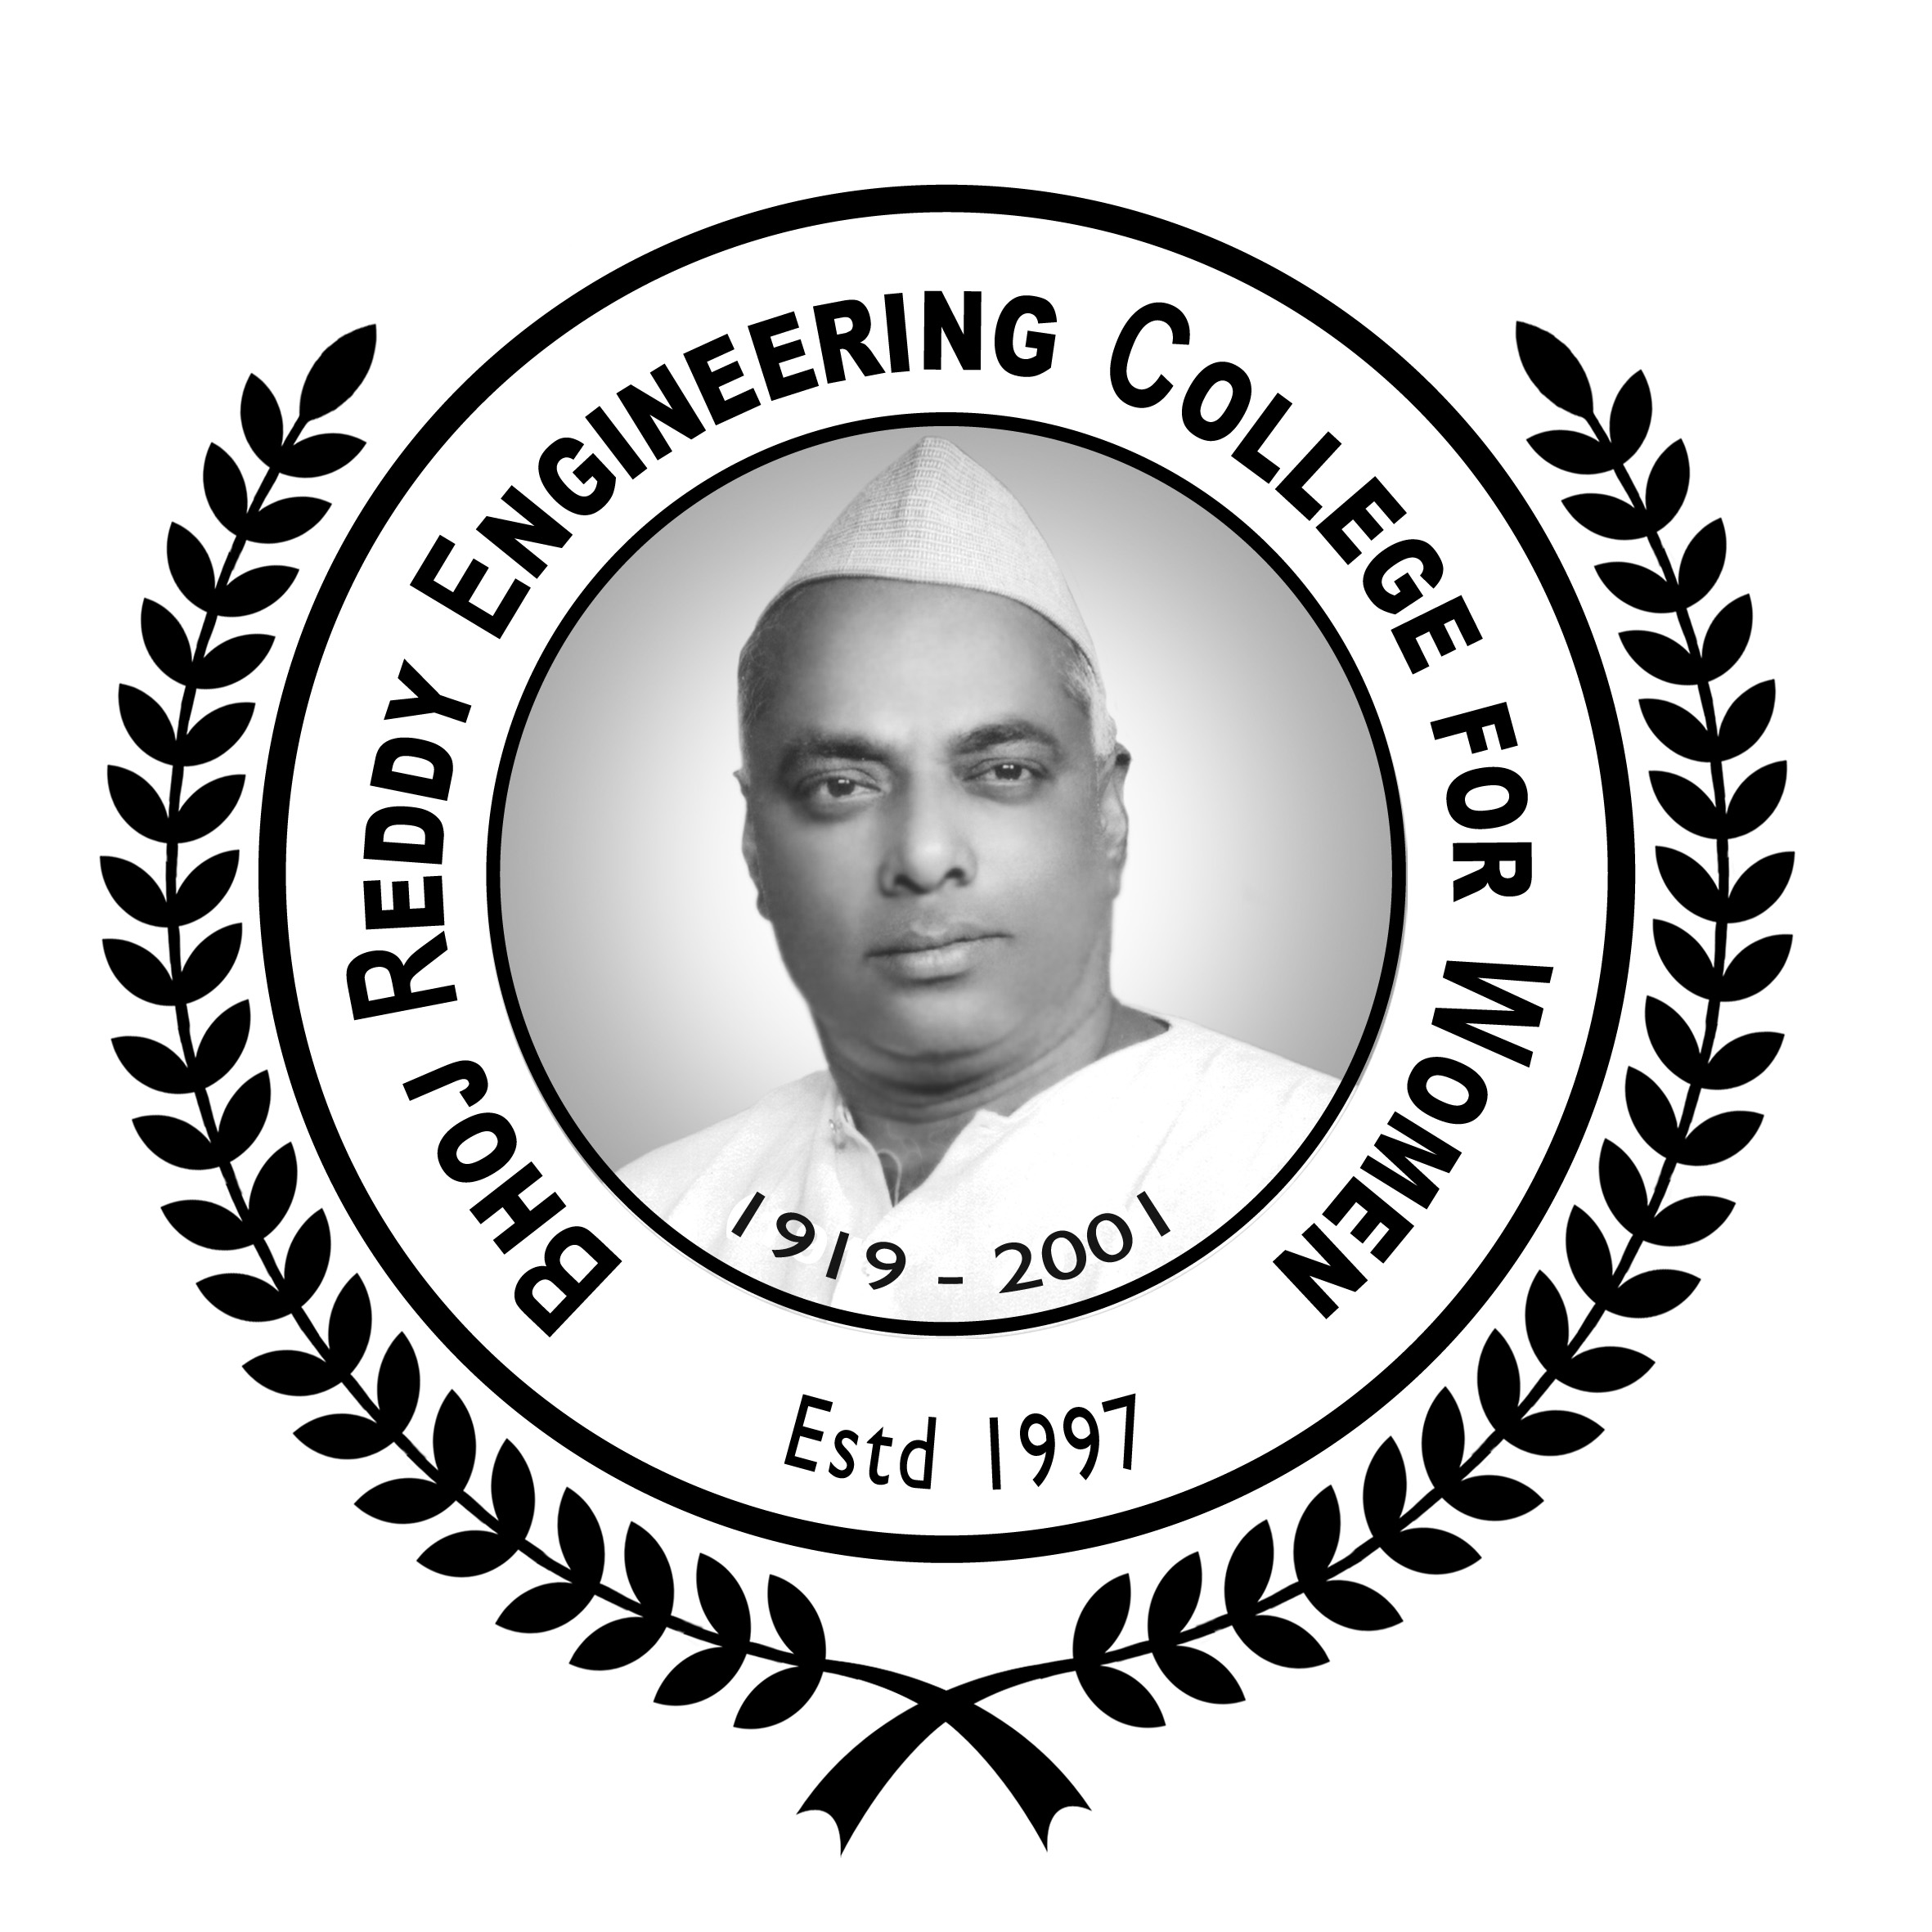 | Bhoj Reddy Engineering College for Women  (Sponsored by Sangam Laxmibai Vidyapeet, approved by AICTE and affiliated to JNTUH)  Vinaynagar, Santoshnagar Crossroads, Saidabad, Hyderabad – 500 059  Phones: 040-2459 2400 Fax: 040-2453 7281 Email: principal@brecw.ac.in Website: www.brecw.ac.in
Notification for Admission to all Category `B’ Seats
(widely known as Management Seats)
for Bachelor of Technology (B Tech) Course
in CSE, ECE, EEE and IT Branches for the academic year 2015-16
based on JEE-Main-2015, EAMCET-2015 Ranks and Intermediate (10+2) Marks

References:
- GO Ms No 74, Higher Education (EC-2) Department, Dated 28-07-2011
- GO Ms No 66, Higher Education (EC-2) Department, Dated 03-09-2012
- GO Ms No 42, Higher Education (EC-2) Department, Dated 05-08-2014
- GO Ms No 13, Higher Education (EC-2) Department, Dated 14-08-2014
- Notification & Guidelines of APSCHE, Dated 20.08.2014

1. |  | General
1.1 |  | This college is sponsored and managed by Sangam Laxmibai Vidyapeet, a not-for-profit educational society with 63 years of experience in the field of education for girls and women.
1.2 |  | As the name of the college indicates, admissions to this college are open to women only.
1.3 |  | Only those students who are interested in studying the B Tech Course are advised to apply.
1.4 |  | Only those who want to study in any of the following four branches that are offered by this college are advised to apply.  - Computer Science and Engineering (CSE)  - Electronics and Communication Engineering (ECE)  - Electrical and Electronics Engineering (EEE)  - Information Technology (IT)
1.5 |  | Only those who would like to study specifically in Bhoj Reddy Engineering College for Women are advised to apply.
1.6 |  | This college is not meant for a student who would simply like to be known as “an engineering student” and who, in fact, does not really have any interest in the engineering course.
1.7 |  | The above points are included in this notification with a view to motivate the students, who are serious in pursuing B Tech Course specifically in this college, to seek admission in this college. These are also meant to facilitate admissions for the Category B Seats, which are widely known as management seats, in a fair, transparent and non-exploitative manner, on merit, based on JEE-Main, EAMCET Rank and on Intermediate (10+2) Marks.
1.8 |  | Numbers of seats available in each branch of B Tech in this college under Category B are: (a) CSE-36, (b) ECE-54, (c) EEE-18 and (d) IT-36.
2. |  | Application Form
2.1 |  | Along with this notification (containing the norms and procedure for admission to category B seats), an information brochure on the college and a blank application form are placed on the website of the college: www.brecw.ac.in. Any student interested in seeking admission to this college may download the application form, the admission notification and the information brochure from the website.
2.2 |  | The above mentioned documents are also available free of cost from the administrative office of the college, not only on working days but also on holidays from 9 am to 5 pm.
3. |  | Eligibility to apply
3.1 |  | Three categories of students are eligible to apply: (i) a student who has been given a rank in JEE-Main-2015 and (ii) a student who has been given a rank in EAMCET-2015 and (iii) a student who have passed and obtained not less than 45% of marks in the Intermediate (10+2) Examination.
4. |  | Submission of filled-up application
4.1 |  | The prospective applicant, along with her parents and/or guardian, is requested to go through (a) the admission notification, (b) the information brochure and (c) the application form.
4.2 |  | Only after becoming familiar with the details given in the information brochure and the admission notification, the prospective applicant may fill up the application form.
4.3 |  | The applicant should furnish all information sought in the application form and attach the photocopies of the documents, as clearly stated in the application form. The applicant as well as her parent or guardian must sign on photocopy of every document, to indicate that it is a photocopy of a genuine document.
4.4 |  | The filled-up application form, along with the photocopies of the required documents, should carry a crossed demand draft for Rs 5000 (Rupees five thousand) drawn in favour of `Bhoj Reddy Engineering College for Women’ and payable at Hyderabad, towards fee for registration and processing of application and for completion of the admission process. This registration fee once paid shall not be refunded in any case at any point of time.
4.5 |  | The filled-up original application form, with photocopies of the required documents and the demand draft, and a photocopy of the filled-up application form should be submitted personally by the applicant and her parent/guardian to Shri K Vijaya Bhasker Reddy, Superintendent, Administrative Department of the College. An official acknowledgment will be issued for the filled-up original application form by recording date and time of registration, entering registration number, putting his signature and affixing college stamp on the photocopy of the filled-up application form for applicant’s record. The registration will be done not only on working days but also on holidays, between 9 am and 5 pm.
4.6 |  | The last date for registration is 27th July 2015, Monday, up to 5 pm. Thus, the process of registration of applicants comes to an end.
5. |  | Display of merit lists and intimation of counselling timings
5.1 |  | List of all registered applicants – in order of priority (i) JEE-Main ranks (ii) EAMCET ranks and (iii) percentage of Intermediate (10+2) marks – will be displayed by 3 pm on 28th July 2015, Tuesday, on the college notice board as well as on the college website. The list can also be collected from the administrative office of the college, free of cost.
5.2 |  | The list will clearly indicate the time for selection of the branch by the applicant and the allotment of the seat by the management. This process will be in batches, in order of merit and as per the schedule specified in the list.
5.3 |  | No request for change in the scheduled time, on any ground at any time of the admission process, will be entertained. An absentee applicant will be treated as an applicant who is not interested in admission to this college.
6. |  | Open Admission Counselling
6.1 |  | Selection of branch, allotment of seat, payment of tuition fee, and admission to the course through open admission counselling on 30th July 2015, Thursday (as per schedule only).
6.2 |  | The open admission counselling will be held in the campus of the college which is located in Vinaynagar, Santoshnagar Crossroads, Saidabad, Hyderabad – 500 059.
6.3 |  | The registered applicants, who would like to participate in the open admission counselling, are requested to get familiar with the location of the college, well in advance of the open admission counselling date.
6.4 |  | The registered applicant should bring all original documents for the seat selection and allotment process at the scheduled time.
6.5 |  | The registered applicant, who is participating in the seat selection and allotment process, should bring a crossed bank demand draft for Rs 47,300 (Rupees forty seven thousand and three hundred only) drawn in favour of `Bhoj Reddy Engineering College for Women’, payable at Hyderabad, towards annual tuition fee and special fee for 2015-16, the first academic year of the B Tech Course. As and when the tuition fee for the remaining years is revised by the competent authority, the admitted student has to pay the difference.
6.6 |  | The annual tuition fee for each of the four academic years (2015-16, 2016-17, 2017-18 and 2018-19) will continue to be the same, unless and until it is changed by the competent authority.
6.7 |  | The entire process of selection of branch, allotment of seat and payment of tuition fee will be done in the college campus. The registered applicant, along with a parent or a guardian (one only), should reach the campus of the college one hour in advance of the scheduled time. She should get formalities such as verification of certificates completed and be ready by the scheduled time for selection of branch by her and allotment of seat by the management.
6.8 |  | For the purpose of admission counselling, the registered applicants will be called in order of merit.
6.9 |  | There will be three display boards – (i) in the general waiting hall, (ii) in the selection waiting hall and (iii) in the selection hall itself. The branch-wise lists of seats for which admissions are done, with names of the admitted students, and the branch-wise number of seats that are still available will be continuously updated on the display boards.
6.10 |  | As soon as a registered applicant, who has been called for selecting a branch, enters the selection hall, she will be given a statement (in duplicate) which will contain the branch-wise list of admitted students, and the number of seats still available in each branch. Based on that statement, she will be requested to select a branch in which seats are available. The registered applicant, participating in the admission process, will have to record her choice, on the statement given to her, of the branch in which seats are still available and the accompanying parent or guardian, also has to sign the statement and return one copy to the college and retain the second copy for her record.
6.11 |  | If a seat in the branch of her choice is not available and the registered applicant does not want to take a seat that is available in other branches, she has to record her decision on the statement that was given to her and sign it. The accompanying parent or guardian also has to sign in the statement. One signed copy should be returned to the college and the second copy should be retained by the applicant for her record. Such student may leave the selection hall and the college campus since no further formalities need to be completed.
6.12 |  | Once a branch is selected by the applicant from among the branches in which seats are available and the seat in the selected branch is allotted by the management to her, the applicant has to submit her original certificates and the demand draft to Shri K Vijaya Bhasker Reddy, Superintendent, Administrative Department of the College, and obtain an acknowledgment for the documents and the bank DD. A letter of admission will be given and its receipt must be acknowledged by the admitted student and by the parent or guardian accompanying the student. The admitted student’s name will be immediately and simultaneously entered on the display boards in the general waiting hall, the selection waiting hall and the selection hall itself. Thus, the admission process comes to an end for each admitted student. There will not be any changes in the admissions already done.
6.13 |  | The tuition fee for the first academic year (2015-16), which is paid by the registered applicant at the time of her being admitted to the college, is non-refundable as the admission process is completed. A written undertaking to this effect has to be signed by the admitted student and the parent or guardian accompanying the student on a stamped paper in specified format.
6.14 |  | The date of the commencement of the first year of the B Tech Course will be announced in the media by various authorities: Jawaharlal Nehru Technological University Hyderabad (JNTUH), Telangana State Council of Higher Education (TSCHE), etc. The college also will notify the same on its notice board and its website. The students, who are admitted to this college, in category B seats, are requested to keep themselves updated in this regard and attend the college from the day one itself.
7. |  | Appeal
7.1 |  | The College Management would like to assure all students, who are interested in joining this college to pursue their B Tech Course under category B seats (i.e. management seats), that the College Management will not deviate from the procedure specified in this notification. The same assurance is given to the parents and guardians of such students.
7.2 |  | Each admitted student and her parent or guardian accompanying the student have to give a joint undertaking that they are fully aware of the norms and procedure specified for admission to the management seats, that they are satisfied with the specified norms and procedure, and that they will adhere to the specified norms and procedure.
7.3 |  | No recommendation and/or intermediation will be entertained. All interested students and their parents/guardians are requested to directly interact only with Shri K Vijaya Bhasker Reddy, Superintendent, Administrative Branch of the College, who has been authorized by the College Management to supervise the process of admission to the Management Seats in accordance with the norms and procedure specified herein. No one else is authorised by the College Management to intervene in the admission process. Students and their parents/guardians are advised not to use services of any consultant or intermediary in this process.
7.4 |  | The students seeking admission into this college and their parents/ guardians are requested to cooperate with the College Management so that the process of admissions to the management seats is conducted and completed in a fair, transparent and non-exploitative manner.
7.5 |  | Many thanks for reading this admission notification carefully.

Hyderabad, 20th July 2015 M Ramlakshmi, President
Bhoj Reddy Engineering College for Women

Attachments: 1. College Information Brochure
2. Application Form
3. Admission Bond Format

Important Dates

1 | Date of Admission Notification | 20th July 2015
2 | Last date for submitting applications | 27th July 2015 upto 5.00 pm
3 | Display of merit list and intimation of counselling timing with guidelines on open admission counseling | 28th July 2015 3.00 pm
4 | Date of open admission counselling | 30th July 2015  (as per schedule)

Check-list for Open Admission Counselling on 30th July 2015, Thursday

1 | The registered applicants are requested to note the scheduled timings for scrutiny of documents, for selection of branch and for admission.
2 | The registered applicants are requested to bring the following documents in original, with two photocopies
(i) JEE-Main Rank Card

(ii) EAMCET Rank Card

 | (iii) Intermediate (10+2) Marks Sheet
 | (iv) SSC Certificate
 | (v) Transfer Certificate
3 | Four (4) passport size colour photographs
4 | A crossed bank demand draft for Rs 47,300 (Rupees forty seven thousand and three hundred) drawn in favour of Bhoj Reddy Engineering College for Women, payable at Hyderabad, towards annual tuition fee and special for the first academic year of 2015-16. The payment of fee has to be only through crossed DD. Cash, cheque, etc will not be accepted.

